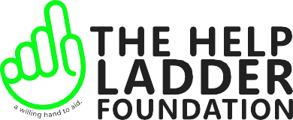

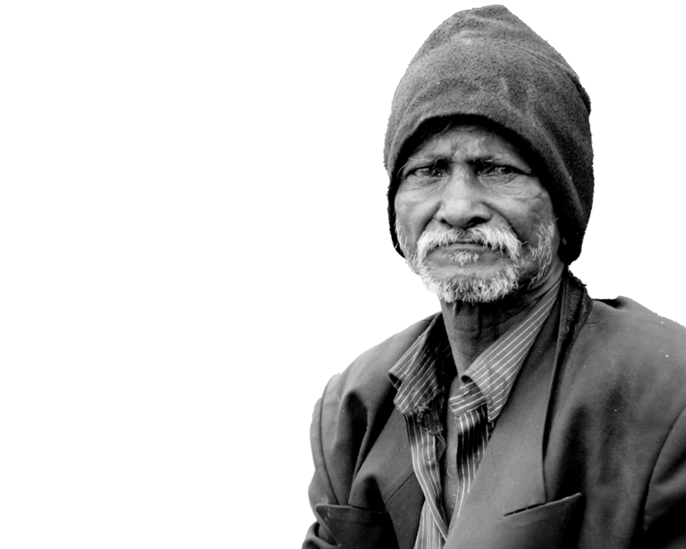

THE HELP LADDER FOUNDATION

A Willing Hand To Aid

[www.thlftrust.org](http://www.thlftrust.org/)

# Our Campaign!

“We are powered by a belief that a better world – free from hunger, poverty and illiteracy is possible with a strong aim to guide and serve the needy.”

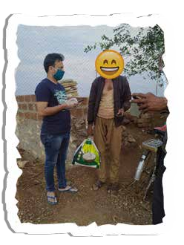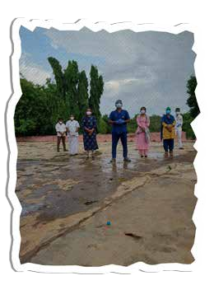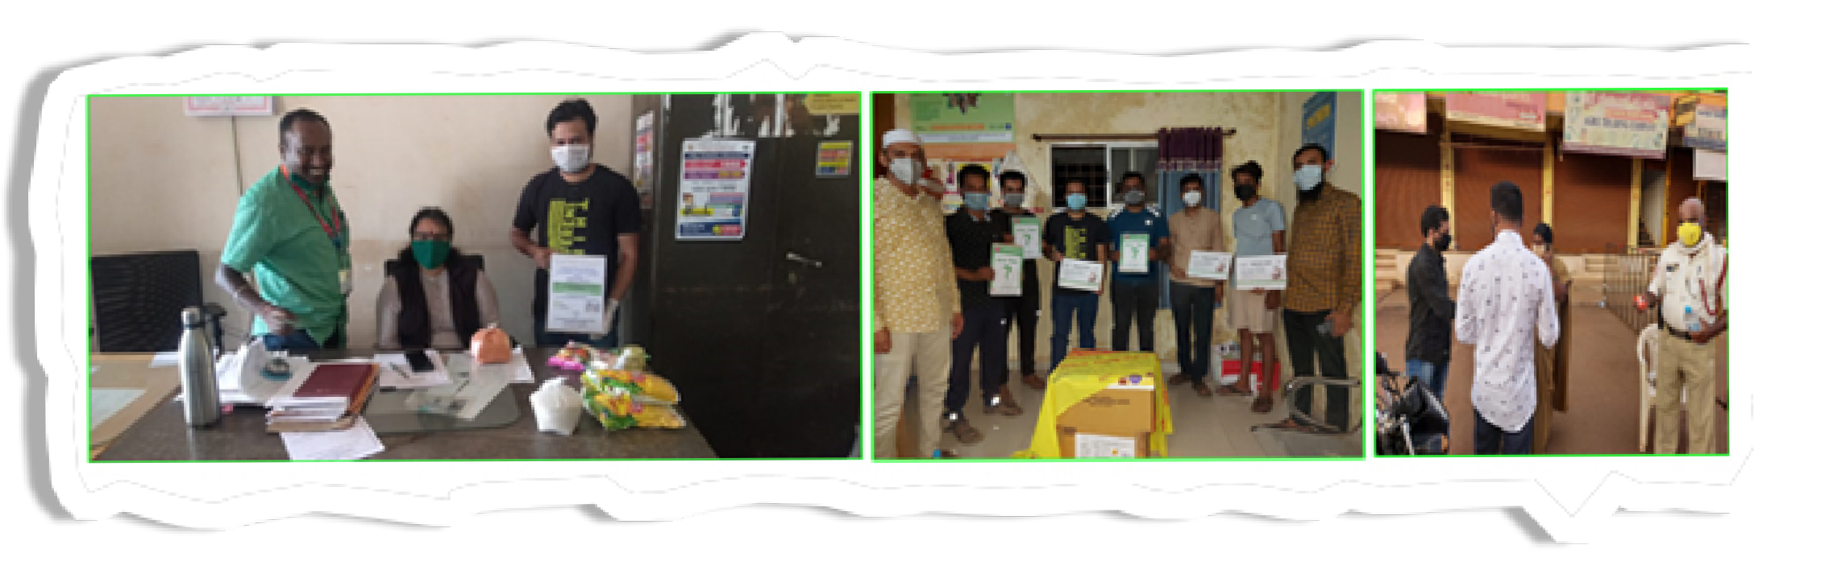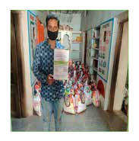

Every person has the right to access resources and oppor- tunities in order to live and develop with dig- nity and to become an active and contribut- ing member of society.

We have structured programs to alleviate suffering and poverty by helping people build secure and pro- ductive communities with Humanitarian Aid- Micro ﬁnancing, Education and by

creating awareness camps and so on.Med- ical Aid, Disaster relief management, Com- munity development by creating awareness camps and so on.

# Who We Are?

The Help Ladder Foundation (THLF) is one of strongest crowdfunding youth volunteer Not for Proﬁt organi- zation HQ at Basavakalyan District Bidar north Karnataka India.



With an AIM to promote a speciﬁc cause and restore hope for a better future, THLF was seeded on 11th No- vember 2020 to contribute with every fragment of help possible to the sparkling change with most active and innovative efforts reﬂect- ing transparency in all affairs.

***“****Among a global pandemic*

*a wave of health, growing economic inequality and climate crisis has sent ripples across the whole world. Thus, THLF managed to empower new generation to shape the future and help communities in need of ﬁnancial support to go through the major crisis and withstand the storm of challenges****”***

# Our Squad!

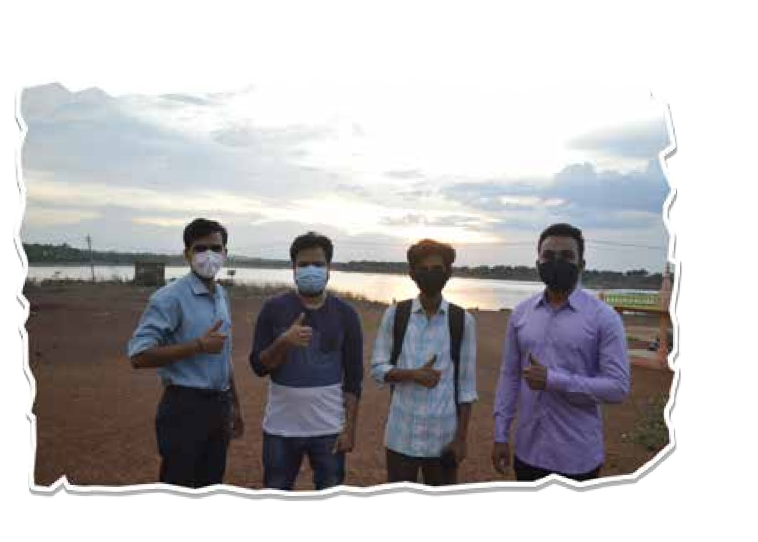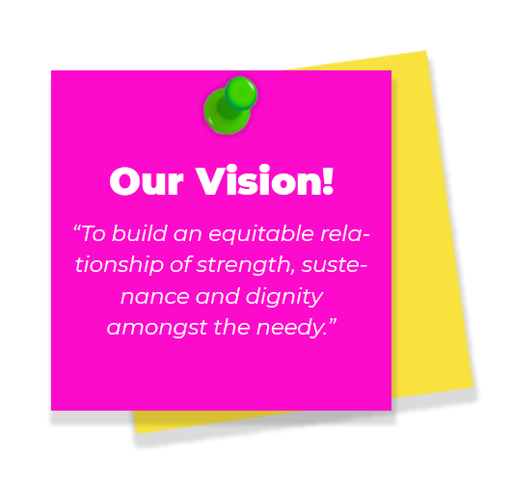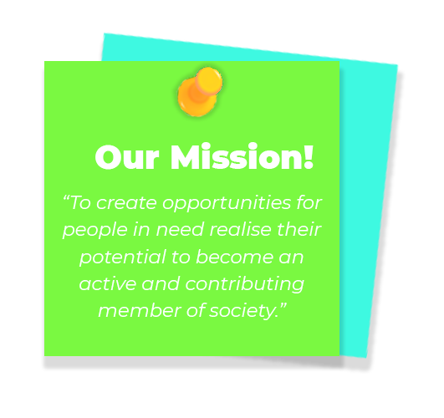

Team at THLF is driven by a passion to serve the needy, who comes with a collec- tive responsibility, commitment, dedica- tion and willingness to go on even when things are on bleak.

# Our Collaboration!

*“Alone we can do so little, together we can do* ***much.” – Helen Keller***

*We are entrusted & collaborated with the following other NGO’s, local & state authorities:*

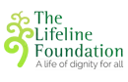

Department Health & Family Welfare

**Karnataka State Police**

Basavakalyan

**City Municipal Council**

Basavakalyan

**CMC**

**Taluka Administration**

Basavakalyan



# Join us!

**Md Rizwan Baag**

(+91 9341016434)

Social Leader | Founding Trustee

*You too have stake in this collective responsibility.*

*Your donations do “make a difference” -Kindly contribute.*

*rather raise our standard of Giving.*



*When we are blessed ﬁnancially let’s not only raise our standard of Living*

#13-61 Saher Enclave Dharagiri Street, Near Basaveshwar Temple Basa- vakalyan 585327 Dist- Bidar Karnataka

Email: [support@thlftrust.org](mailto:support@thlftrust.org) [www.thlftrust.org](http://www.thlftrust.org/)